- Login into your account on orwallbaseball.com

- Click the square that says Volunteer Opportunities.
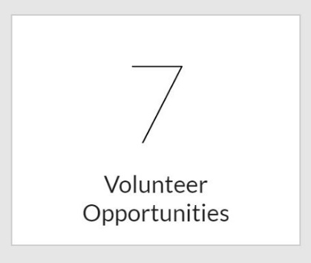

- Look for the colored button on the right side of the screen that says Find Volunteer Roles.

- Select the box that says your desired role.
- Click sign up as a registered user (or as a new user if you are not currently on the account).
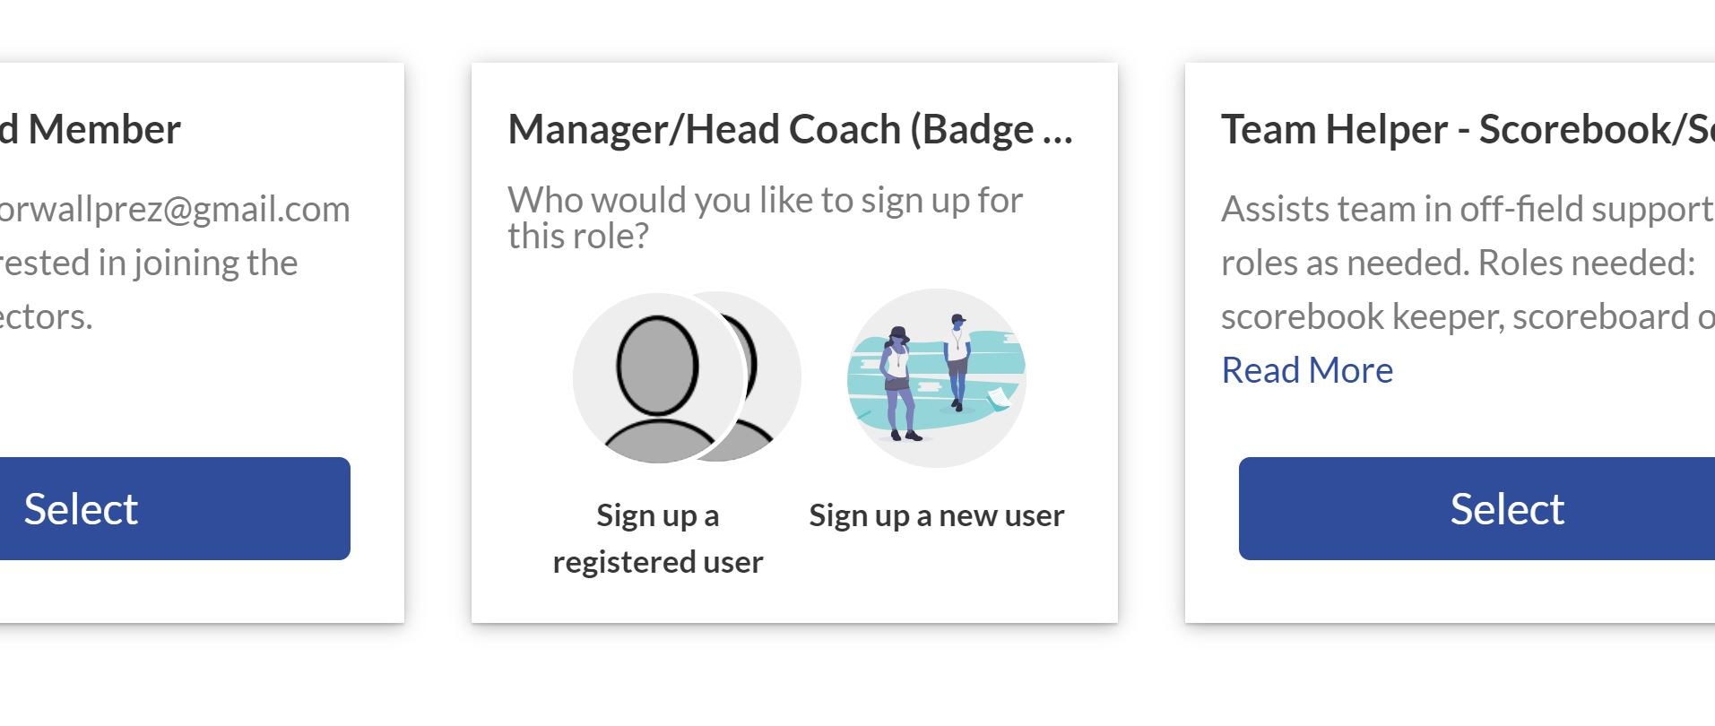
- Choose the correct person for the volunteer role you are signing up for.
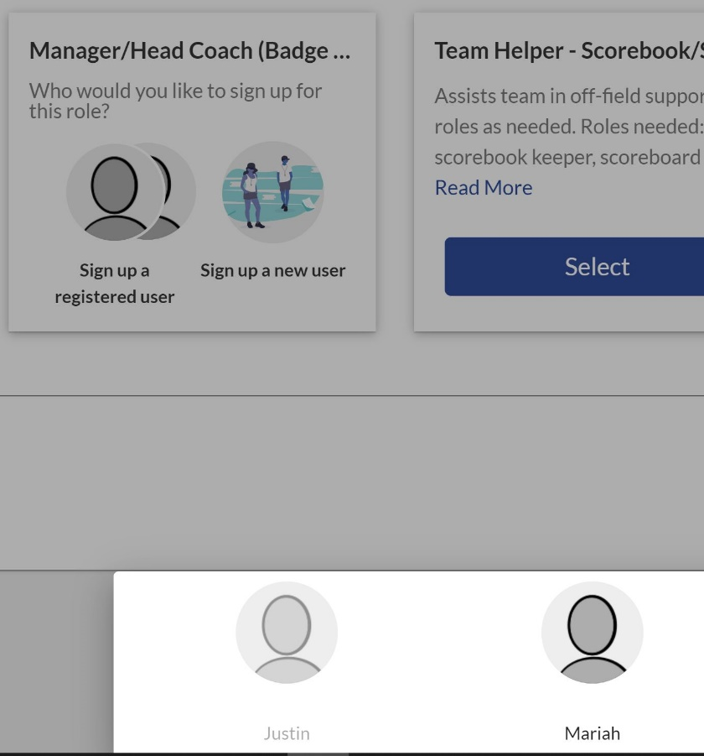

- Then press the blue Continue button in the bottom right corner.
- The next page will ask for your information and this information is collected securely by our website. These items are required for your background check and to issue a badge. You will also need to upload a photo of your driver’s license and a photo of yourself (shoulders up, no hat or sunglasses).
- Once you complete the page, click the blue Continue button in the bottom right corner.
- Once we have sent your information in for the background check, you will receive an email with the subject line: "ORWALL LITTLE LEAGUE Background Questionnaire Notification." Please read and complete the process outlined (it only takes a few minutes). If you do not complete this portion, you will not be eligible to receive a badge as your background check will not have been completed.
Thank you!

